Task01

What kind of collision resolution strategy is implemented in the below Hash Table ?

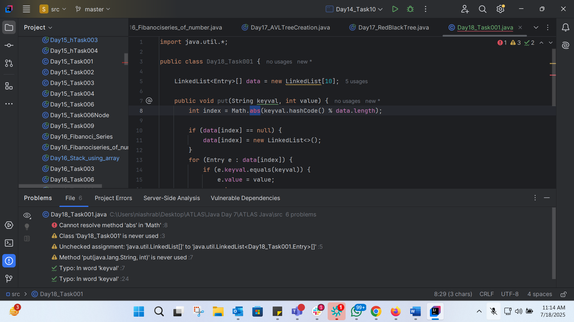
ANS:
Chaining using a Linked List
EXP:
- Each index of the data array contains a LinkedList of Entry objects.
- When a collision occurs (i.e., two keys hash to the same index), the new Entry object is simply added to the end of the LinkedList at that index.

Task2: Wap to take input from the user a 5 digit no and display digit by digit in the output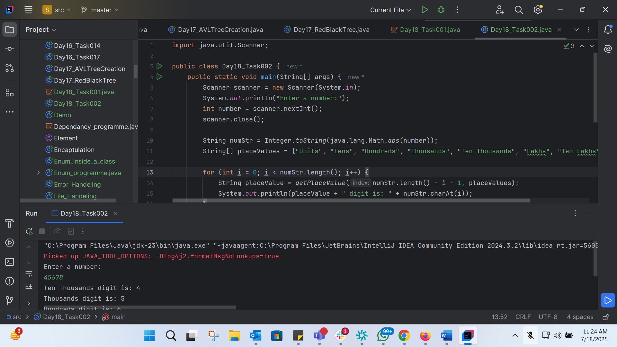
import java.util.Scanner;
public class Day18_Task002 {
public static void main(String[] args) {
Scanner scanner = new Scanner(System.in);
System.out.println("Enter a number:");
int number = scanner.nextInt();
scanner.close();
String numStr = Integer.toString(java.lang.Math.abs(number));
String[] placeValues = {"Units", "Tens", "Hundreds", "Thousands", "Ten Thousands", "Lakhs", "Ten Lakhs", "Crores"};
for (int i = 0; i < numStr.length(); i++) {
String placeValue = getPlaceValue(numStr.length() - i - 1, placeValues);
System.out.println(placeValue + " digit is: " + numStr.charAt(i));
}
}
private static String getPlaceValue(int index, String[] placeValues) {
if (index < placeValues.length) {
return placeValues[index];
} else {
return (int) java.lang.Math.pow(10, index) + "";
}
}
}

Task3: Wap to take number from the user and display the no of digit it has
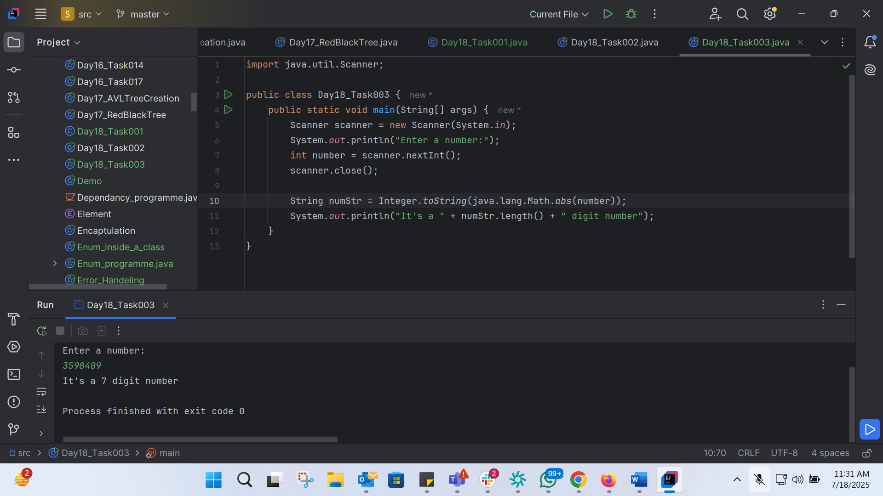
import java.util.Scanner;
public class Day18_Task003 {
public static void main(String[] args) {
Scanner scanner = new Scanner(System.in);
System.out.println("Enter a number:");
int number = scanner.nextInt();
scanner.close();
String numStr = Integer.toString(java.lang.Math.abs(number));
System.out.println("It's a " + numStr.length() + " digit number");
}
}

Task 4:
What are the applications of heap sort?:
- Sorting Large Datasets
- Priority Queues
- Event Handling
- Resource Allocation
- Database Systems
Task 5:
Do you find any significance change between the breadthFirstSearchRecursive() approach compared to the standard BFS?

- Will it need for queues entirely by using a stack-based recursion?

- Will it simplifies implementation by using queues implicitly within recursive function calls?

- will it achieve same result but emphasizes on recursive style using the same level-order logic with explicit queue management?

or
- will it processes nodes in post-order sequence to avoid memory allocation?

Task 6:
How does heap sort work ? explain the technique in 5 .. algorithm
- Building a Heap
- Heapify
- Removing the Maximum Element
- Heapify the Reduced Heap
- Repeating the Process

Task 7:
how can you say recursive functions maintain the state of each call during execution?

1. Each recursive call creates a new thread, and context switching maintains state.

2. Recursive functions store state in global variables accessible across calls.

3. The system call stack tracks local variables and return addresses for each recursive invocation.

4. Recursive functions replicate the heap structure to keep values between calls.

Task 8: Can you print the corner nodes of a binary search tree?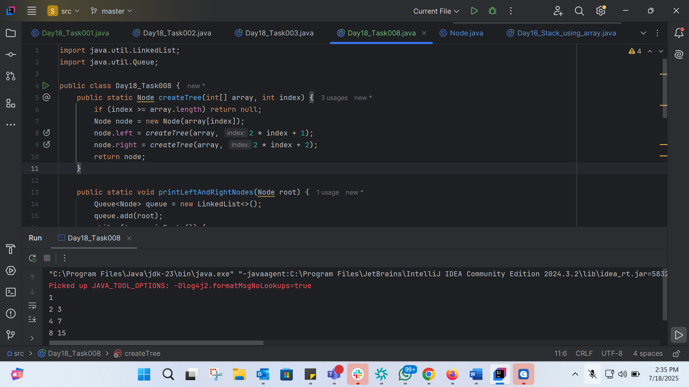
import java.util.LinkedList;
import java.util.Queue;
public class Day18_Task008 {
public static Node createTree(int[] array, int index) {
if (index >= array.length) return null;
Node node = new Node(array[index]);
node.left = createTree(array, 2 * index + 1);
node.right = createTree(array, 2 * index + 2);
return node;
}
public static void printLeftAndRightNodes(Node root) {
Queue<Node> queue = new LinkedList<>();
queue.add(root);
while (!queue.isEmpty()) {
int levelSize = queue.size();
boolean first = true;
for (int i = 0; i < levelSize; i++) {
Node currentNode = queue.poll();
if (i == 0 || i == levelSize - 1) {
if (!first) System.out.print(" ");
System.out.print(currentNode.data);
first = false;
}
if (currentNode.left != null) queue.add(currentNode.left);
if (currentNode.right != null) queue.add(currentNode.right);
}
System.out.println();
}
}
public static void main(String[] args) {
int[] array = {1, 2, 3, 4, 5, 6, 7, 8, 9, 10, 11, 12, 13, 14, 15};
Node root = createTree(array, 0);
printLeftAndRightNodes(root);
}
}

Task 09: recap of Quiz qn

What is the main purpose of using a binary heap in the implementation of a priority queue?

1. To maintain keys in alphabetical order for efficient string processing.
2. To ensure that the highest-priority element always bubbles to the root efficiently.
3. To guarantee constant-time insertion and logarithmic-time deletion.
4. To reduce memory consumption by flattening the tree into a linear array.

Task 10: Can you print the corner nodes of a binary search tree?
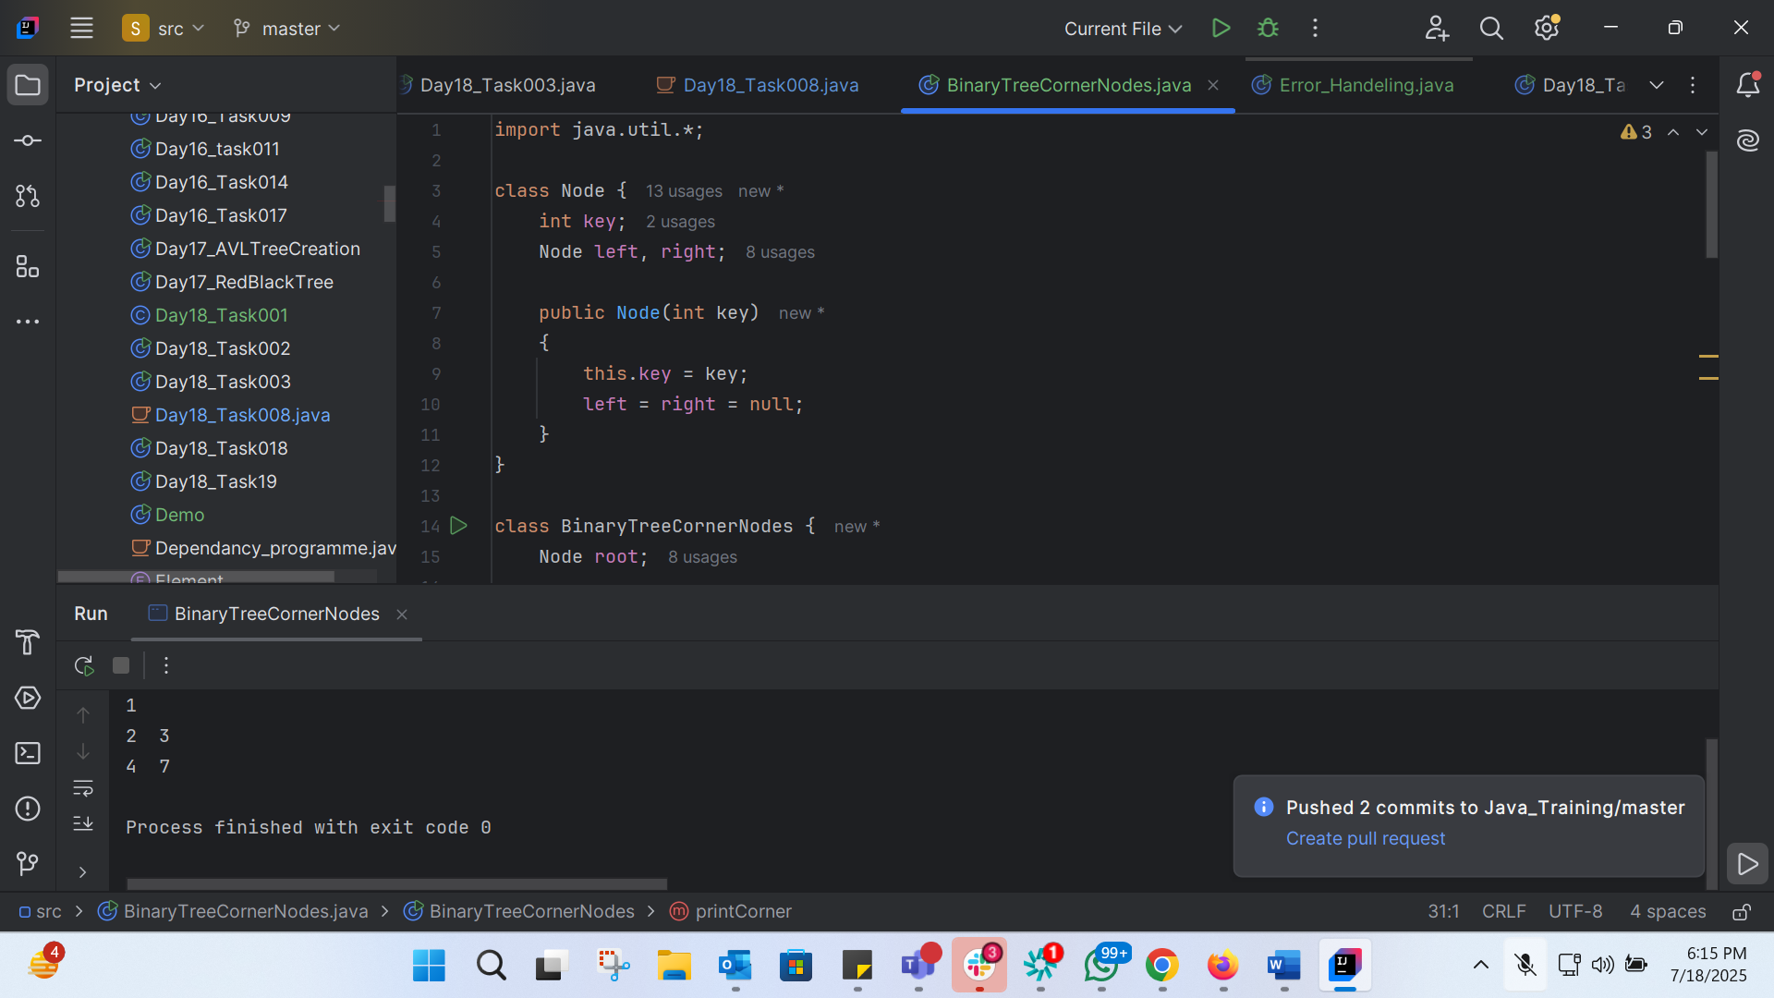
import java.util.*;
class Node {
int key;
Node left, right;
public Node(int key)
{
this.key = key;
left = right = null;
}
}
class BinaryTreeCornerNodes {
Node root;
void printCorner(Node root) {
Queue<Node> q = new LinkedList<Node>();
q.add(root);
// level order traversal
while (!q.isEmpty()) {
int n = q.size();
for(int i = 0 ; i < n ; i++){
Node temp = q.peek();
q.poll();// retrieve and remove the node
if(i==0 || i==n-1)
System.out.print(temp.key + " ");
if (temp.left != null)
q.add(temp.left);
if (temp.right != null)
q.add(temp.right);
}
System.out.println();
}
}
public static void main(String[] args){
BinaryTreeCornerNodes tree = new BinaryTreeCornerNodes();
tree.root = new Node(1);
tree.root.left = new Node(2);
tree.root.right = new Node(3);
tree.root.left.left = new Node(4);
tree.root.left.right = new Node(5);
tree.root.right.left = new Node(6);
tree.root.right.right = new Node(7);
tree.printCorner(tree.root);
}
}

Task 11:

Which concept explains how recursive functions maintain the state of each call during execution?

1. Each recursive call creates a new thread, and context switching maintains state.
2. Recursive functions store state in global variables accessible across calls.
3. The system call stack tracks local variables and return addresses for each recursive invocation.
4. Recursive functions replicate the heap structure to keep values between calls.

Task 12:

How does this binary search function behave on unsorted arrays?
public class BinarySearch {
public int search(int[] arr, int target) {
int left = 0, right = arr.length - 1;

while (left <= right) {
int mid = left + (right - left) / 2;

if (arr[mid] == target) {
return mid;
} else if (arr[mid] < target) {
left = mid + 1;
} else {
right = mid - 1;
}
}

return -1;
}
}

1. It works regardless of sorting
2. It throws exception if unsorted
3. It may return incorrect index
4. It sorts before searching

Task 13:
What is the result of performing DFS traversal in this graph implementation?
import java.util.*;

public class DFSGraph {

Map<Integer, List<Integer>> adj = new HashMap<>();

Set<Integer> visited = new HashSet<>();

public void addEdge(int u, int v) {
adj.computeIfAbsent(u, x -> new ArrayList<>()).add(v);
}

public void dfs(int node) {
if (visited.contains(node)) {
return;
}

visited.add(node);
System.out.print(node + " ");

for (int neighbor : adj.getOrDefault(node, new ArrayList<>())) {
dfs(neighbor);
}
}
}

1. DFS uses a queue to ensure order
2. DFS will return shortest path like BFS
3. DFS traverses all nodes depth-first recursively
4. DFS skips connected nodes due to reentrancy issue

Task 14:

Why is BFS generally preferred over DFS in shortest path algorithms for unweighted graphs?

1. BFS uses random access to edges, ensuring constant-time traversal.
2. BFS explores one path to maximum depth before switching, reducing memory usage.
3. BFS ignores revisiting nodes, reducing processing time in cyclic graphs.
4. BFS explores nodes in increasing distance order from the source, ensuring shortest paths are found first.

Task 15:
Write algo for radix sort
1. Find the maximum element in the array to determine the number of digits.
2. Initialize 10 buckets (one for each digit from 0 to 9).
3. Iterate through each digit position (from least significant to most significant):
- Distribute the elements into the buckets based on the current digit.
- Collect the elements from the buckets back into the array.
4. Repeat step 3 until all digit positions have been processed.

Task 16:
the pseudo code for Radix Sort:
FUNCTION RadixSort(arr)
max_element = FIND_MAX(arr)
digits = NUMBER_OF_DIGITS(max_element)

FOR i FROM 0 TO digits-1
buckets = INITIALIZE_BUCKETS(10)

FOR EACH element IN arr
digit = GET_DIGIT(element, i)
ADD_TO_BUCKET(buckets, digit, element)

arr = COLLECT_FROM_BUCKETS(buckets)

RETURN arr

FUNCTION FIND_MAX(arr)
max_element = arr[0]
FOR EACH element IN arr
IF element > max_element
max_element = element
RETURN max_element

FUNCTION NUMBER_OF_DIGITS(n)
count = 0
WHILE n > 0
count = count + 1
n = n / 10
RETURN count

FUNCTION GET_DIGIT(n, i)
RETURN (n / 10^i) MOD 10

FUNCTION INITIALIZE_BUCKETS(size)
buckets = []
FOR i FROM 0 TO size-1
buckets[i] = []
RETURN buckets

FUNCTION ADD_TO_BUCKET(buckets, digit, element)
buckets[digit].APPEND(element)

FUNCTION COLLECT_FROM_BUCKETS(buckets)
arr = []
FOR EACH bucket IN buckets
FOR EACH element IN bucket
arr.APPEND(element)
RETURN arr
Task 17: Write code for radix sort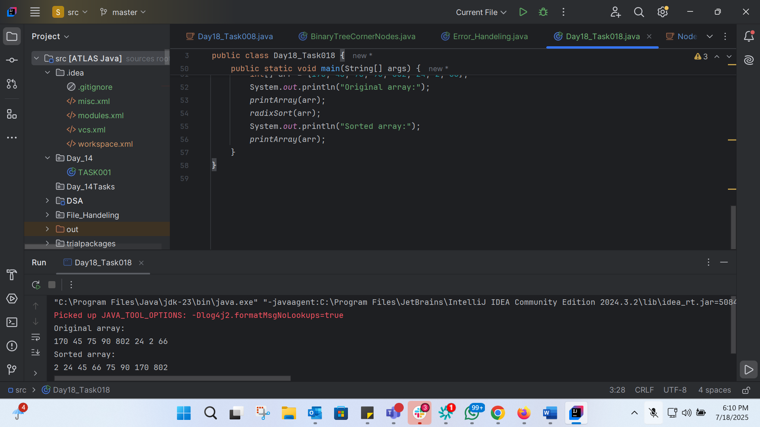
import java.util.*;
public class Day18_Task018 {
public static void radixSort(int[] arr) {
int max = getMax(arr);
int pos = 1;
while (max / pos > 0) {
countSort(arr, pos);
pos *= 10;
}
}
private static int getMax(int[] arr) {
int max = arr[0];
for (int i = 1; i < arr.length; i++) {
if (arr[i] > max) {
max = arr[i];
}
}
return max;
}
private static void countSort(int[] arr, int pos) {
int[] output = new int[arr.length];
int[] count = new int[10];
for (int i = 0; i < arr.length; i++) {
count[(arr[i] / pos) % 10]++;
}
for (int i = 1; i < 10; i++) {
count[i] += count[i - 1];
}
for (int i = arr.length - 1; i >= 0; i--) {
output[count[(arr[i] / pos) % 10] - 1] = arr[i];
count[(arr[i] / pos) % 10]--;
}
System.arraycopy(output, 0, arr, 0, arr.length);
}
public static void printArray(int[] arr) {
for (int i = 0; i < arr.length; i++) {
System.out.print(arr[i] + " ");
}
System.out.println();
}
public static void main(String[] args) {
int[] arr = {170, 45, 75, 90, 802, 24, 2, 66};
System.out.println("Original array:");
printArray(arr);
radixSort(arr);
System.out.println("Sorted array:");
printArray(arr);
}
}

Task 18:
What causes a stack overflow error in recursive functions?

1. Excessive memory allocation in the heap due to global variables.
2. Infinite iteration loops that do not update the loop variable.
3. Recursion that lacks a proper base case or makes too many nested calls, exhausting the call stack.
4. Function calls that return too quickly without completing the recursion tree. Recursion that lacks a proper base case or makes too many nested calls, exhausting the call stack.
Task 19: Wap to display the groups of digits depending upon the unit digits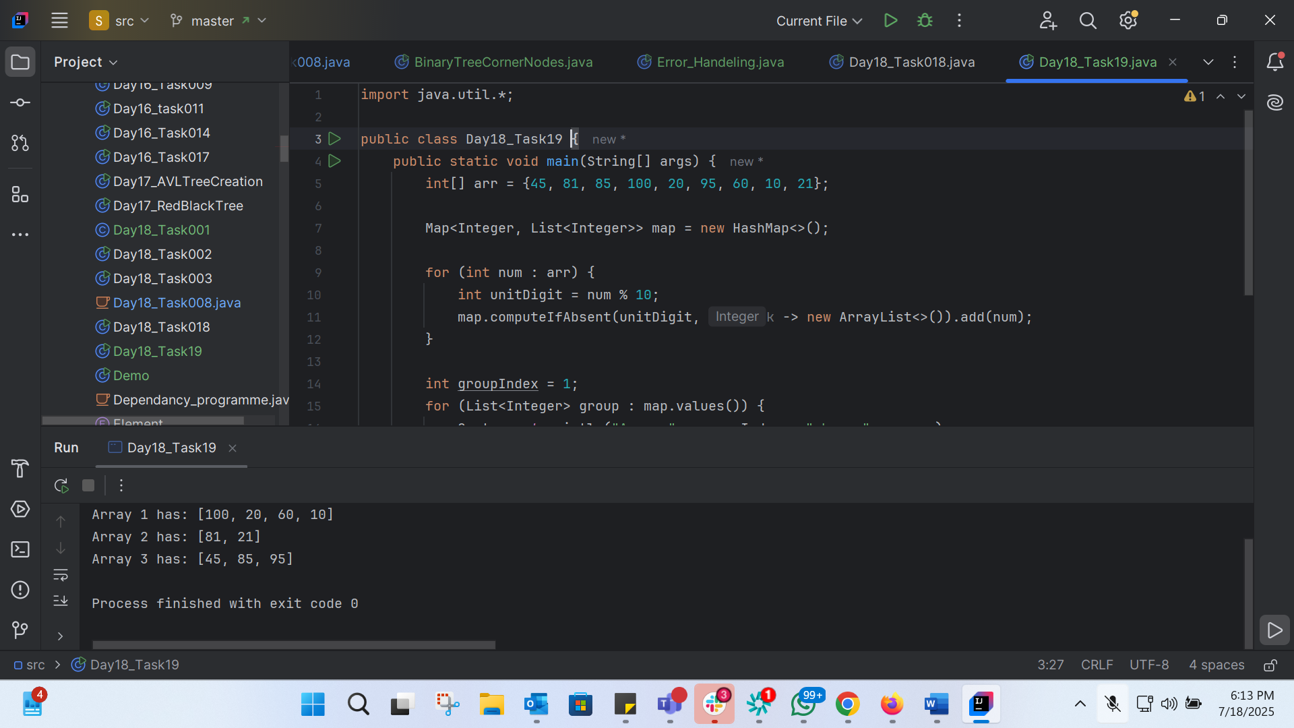
import java.util.*;
public class Day18_Task19 {
public static void main(String[] args) {
int[] arr = {45, 81, 85, 100, 20, 95, 60, 10, 21};
Map<Integer, List<Integer>> map = new HashMap<>();
for (int num : arr) {
int unitDigit = num % 10;
map.computeIfAbsent(unitDigit, k -> new ArrayList<>()).add(num);
}
int groupIndex = 1;
for (List<Integer> group : map.values()) {
System.out.println("Array " + groupIndex + " has: " + group);
groupIndex++;
}
}
}

